

1. **Situation Update**

**KEY HIGHLIGHTS**



* **Four (4) new COVID-19 confirmed cases** have been reported in the last 24 hours bringing the cumulative total of **COVID-19 confirmed cases** in Uganda to **1,029**. No COVID-19 related death has been registered to date.
* **Eighteen (18) non-Ugandan truck drivers** tested positive for COVID-19 and were not allowed entry into the country.
* A total of **197 confirmed cases** **(176 Ugandans; 18 non-Ugandans; 3 refugees)** are currently admitted across **15 health facilities** and a cumulative total of **974 patients** have recovered and been discharged.
* Sixty-one percent (625/1,029) are **imported cases** and 39% are **locally transmitted** (404/1,029).
* A total of **1,702 laboratory samples** were tested today bringing it to a cumulative total of **228,105 samples** tested.
* A cumulative total of **12,970 contacts (1,266 still under follow up)** have been listed to date, **11,704 (90%)** of whom have completed the mandatory 14-day follow up period and been discharged from daily follow up.
* **Two (2) repatriation flights** carrying **46 Ugandan citizens and residents** from Nigeria (26) and South Sudan (20) arrived via Entebbe International Airport and all are under mandatory quarantine.

**Summary of COVID-19 outbreak in Uganda**

|  |  |
| --- | --- |
| **Summary statistics as of 12th July 2020 at 22:00 hrs** | |
| Individuals under institutional quarantine today | 1,616 |
| **Suspected cases** | 00 |
| **Probable cases** | 00 |
| **Total Confirmed Cases** | 1,029 |
| Cumulative deaths (suspected, probable or confirmed) | 00 |
| Health facilities | 00 |
| Community | 00 |
| Deaths among confirmed cases | 00 |
| **Confirmed cases on admission** | 197 |
| **Cumulative number of discharged cases** | 974 |
| Runaways from isolation | 00 |
| Cumulative **contacts** listed | 12,970 |
| **Contacts** that have completed 14 days | 11,704 |
| Number of contacts still under follow up | 1,266 |
| **Contacts** followed up today | 1,231 (97%) |
| Cumulative contacts with symptoms | 460 |
| **Contacts lost to follow up** | 00 |
| Specimens collected and sent to the lab today | 1,702 |
| PoE | 1,433 |
| Contacts and alerts | 269 |
| Health workers | 00 |
| Cumulative specimens collected | 228,105 |
| Number of cases with positive results today | 04 |
| **POE** | 02 |
| **Contacts and alerts** | 02 |
| **Returnees via EIA** | 00 |
| Specimens with pending results | 00 |



**2. Public Health Actions**

**COORDINATION**

* The IMT meeting chaired by the Incident Commander continues to meet twice daily.

**SURVEILLANCE**

* The new confirmed cases include 2 truck drivers who arrived via Kerwa (1) and Mpondwe (1) borders, and 2 community cases from Amuru (1) and Isingiro (1) districts.

**Epidemic curve of confirmed Ugandans (n=1,029)**

**Epidemic curve of Ugandan and non-Ugandan confirmed cases (n=2,533)**

**Distribution of Ugandan cases Age and sex distribution of Ugandan cases**

**Distribution of locally transmitted cases by district of sample collection (n=404)**

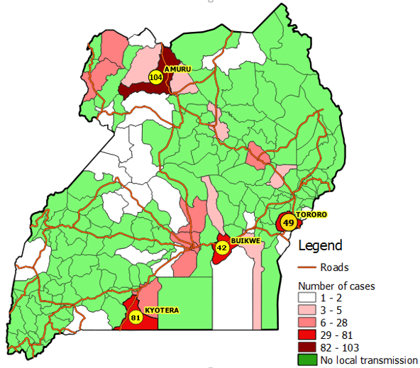

**Comparative analysis of progression of COVID-19 pandemic in East Africa**

* The surveillance pillar continues to conduct **manage alerts**; the table below presents a summary on this:

|  |  |  |
| --- | --- | --- |
| **Variable** | **Indicator** | **Output** |
| **Alerts management** | Incoming calls | 231 |
| Signals not investigated at the end of previous day | 11 |
| New signals received | 47 |
| Total signals | 58 |
| Signals validated for follow-up (Alerts) | 58 |
| Alerts investigated with collection of lab sample | 41 |

**CASE MANAGEMENT**

* There are 197 confirmed cases that are currently admitted across districts in the country and all are in stable condition.

|  |  |  |  |
| --- | --- | --- | --- |
| **Isolation unit** | **No. of confirmed cases on admission** | **Discharges** | **Bed capacity** |
| Entebbe Hospital | 04 | 159 | 125 |
| Masaka RRH  Gulu RRH  Lira RRH  Arua RRH  Mbale RRH  Jinja RRH  Naguru RRH  Mulago NRH | 03  44  23  11  22  23  05  19 | 74  118  28  54  56  54  12  338 | 41  74  20  34  50  28  12  260 |
| Mbarara RRH  Hoima RRH  Mubende RRH  Fort Portal RRH  Adjumani Hospital  Soroti RRH  Kabale RRH  Moroto RRH  Bombo Military Hospital | 09  05  00  01  00  07  09  00  12 | 16  15  22  03  01  17  08  02  00 | 30  16  25  26  02  45  30  30  - |

**RISK COMMUNICATION AND SOCIAL MOBILIZATION**

* A risk communication plan for the returnees through EIA has been developed and will be presented to the IMT.
* The team continues to release daily press briefs to update the general public on the COVID-19 outbreak.

**LOGISTICS**

* Stock status for COVID-19 response:

|  |  |  |
| --- | --- | --- |
| **Item** | **Month of Stock** | **Pipeline Month of Stock** |
| Surgical masks | **0.44** | **1.68** |
| Surgical N95 respirators | **0.20** | **2.60** |
| Face shield | **0.12** | **0.82** |
| Protective goggles | **0.45** | **5.00** |
| Examination gloves | **0.03** | **2.44** |
| Open System (ABI- 7500 SARS COV-2 test) [1 test] | **0.13** | **1.85** |
| SARS-CoV-2 RT-PCR Kit 1.0 [96 tests] | **0.31** | **1.45** |
| Nasopharyngeal swab with Transport Media | **0.48** | **1.18** |

**ICT AND INNOVATIONS**

* The Uganda COVID-19 dashboard can be accessed at <https://covid19.gou.go.ug/>



**3. Challenges**

* Lack of institutional quarantine sites in Kyotera district which is reporting high numbers of local transmission.
* There is no waiting area for truck drivers at Mutukula POE after testing.
* Stock out of IPC supplies; Gowns, N95 Face Masks.
* CTUs are understaffed, with too much work shared among nurses and doctors.
* Need to increase psychosocial support to both the patients and staff to address the ever-increasing stigma and trauma associated with COVID-19.
* Delayed availability of transport for recovered people to resettle them back to their communities.
* Isolation units lack beds and mattresses, beddings for those with expanded admission capacity.



**4. Conclusion**

The Ministry of Health in collaboration with other government ministries, agencies and departments and districts continues to strengthen the COVID-19 outbreak response mechanisms.