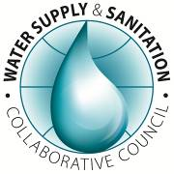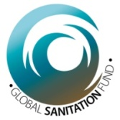

REPUBLIC OF UGANDA

# A REPORT following SOAP DISTRIBUTION EXERCISE IN EASTERN REGION- Emmery MbahA AND RACHEL MIREMBE

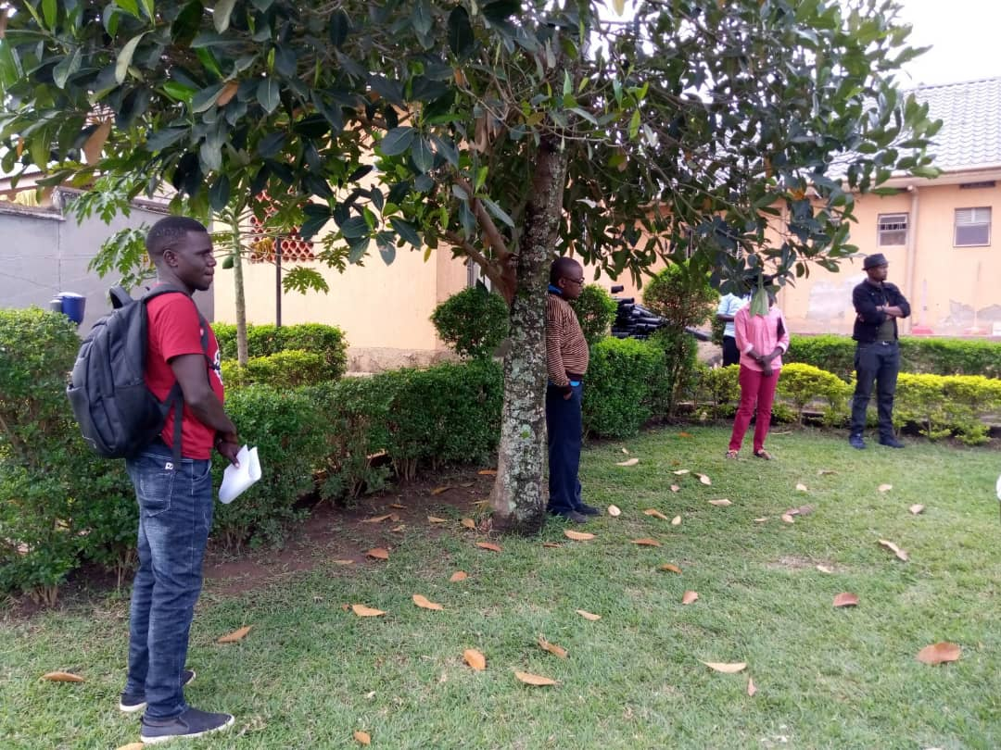

***USF staff Emmery Mbaha and Rachel Faith Mirembe orienting Evidence Action staff on COVD 19 Safety before kicking of the soap distribution exercise in the region.***

***Environmental Health Department; Ministry of Health © April 2020***

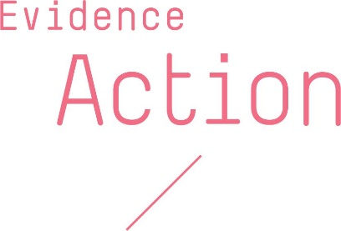 **Supported by**

**DETAILED REPORT, FOLLOWING THE SOAP DISTRIBUTION EXERCISE IN EASTERN REGION.**

**BACKGROUND.**

Uganda reported its first case of Covid19 on March 22. Thereafter the government shared guidelines to curtail further spread of the coronavirus in the country, which covered aspects of social distancing, handwashing and other aspects to stop human-to-human spread. The President of the Republic of Uganda then made a passionate appeal to all development partners, civil society organizations and citizens among others to come in and fully support efforts to combat covid 19 spread in the Country.

It is upon this background that a partner in the name of Evidence Action picked interest to support the beneficiaries of their project in 11 districts in Eastern Uganda to distribute soap in order to promote handwashing, which has proven effective in covid 19 control.

On 30th March 2020, Evidence Action officially wrote to the Permanent Secretary, Ministry of Health seeking guidance on how to distribute 1 kg bar of soap per household in 240,722 households while coordinating with the respective district task forces in order to promote handwashing. On 6th April 2020, the Permanent Secretary Ministry of Health wrote back okaying Evidence Action to distribute soap in liaison with the respective district task forces. However, they were asked to seek guidance from Ministry of Health-Environmental Health Department while implementing the exercise. The Technical Assistant and the Field officer under Uganda Sanitation Fund were assigned duty to provide technical back stopping.

Evidence Action, a health focussed not for profit organization developed this Covid19 prevention hygiene project (CPHP) to contribute towards prevention of the spread of this novel coronavirus in the 11 districts where they operate. They have been implementing Dispensers for Safe Water project since 2014, serving over 1.3 million people in the districts of Budaka, Butaleja, Butebo, Kibuku, Manafwa, Mbale, Namisindwa, Namutumba, Palisa, Sironko and Tororo. It is these very same communities that were targeted to support under CPHP. In this, they sought to promote hand washing, community disinfection and behavioural change towards practices that would prevent the spread of coronavirus.

**PROJECT OBJECTIVES**

In a bid to contribute towards prevention of the spread of Covid19 amongst households in the communities they support, they developed three tracts for intervention as below;

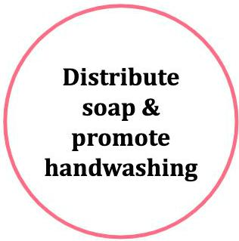

They set out to distribute 722,166 bars of soap to over 240,722 households in the 11 districts where they operate. In this, each household planned to receive a bar of soap over a period of 3 months (1 bar of soap per month). They planned to leverage on their Dispensers for Safe Water (DSW) volunteer promoter infrastructure together with the government health systems (Environmental Health officers, Health Inspectors, Health Assistants) to ensure efficient and effective delivery of soap to the rural households.

Additionally, they have planned to provide promoters with over 45,600 pieces of IEC materials (posters, stickers and talking points) on covid19 in order enable the them promote handwashing and other Covid19 prevention behaviours in their communities.

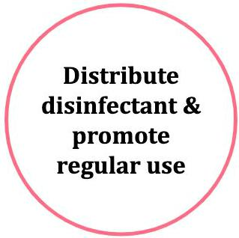

They are also mobilizing their community promoters to disinfect all frequently touched places at water points where they have dispensers, including dispenser valves and water pumps, in their respective areas of operation 3–4 times per day. In this, they have planned to provide promoters with 34,200 litres of disinfectant for this purpose. When delivering supplies, their field staff, together with government staff conduct brief hygiene training sessions, during which they also work with promoters to identify the frequently touched places within their respective water points.

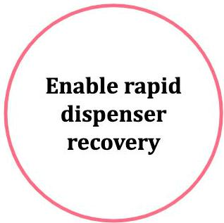

With their dispensers facing an extended period without maintenance, they are proactively delivering an assortment of parts for repairs and also rapidly fixing any currently broken down dispensers and re-stocking chlorine stores. They are also preparing to conduct combined promoter and community education meetings at all water points to address safe water behavioural lapses and/or any misinformation or myths in relation to COVID-19, as well as their impact on the continued use of chlorine dispensers.

**THE APPROACH**

The Environmental Health team (Emmery Mbaha- Technical Assistant, Rachel Mirembe Faith- Field Officer and Nsubuga Emmanuel- Driver) arrived at Evidence Action regional offices in Mbale and had a discussion with management of the distribution plan and strategy. The team then took staff of Evidence Action through the COVID 19 prevention and control guidelines, emphasising personal safety through handwashing, social distancing and effective wearing Personal Protective Equipment. The team then organized a meeting with DHO’s office and RDC’s office in Mbale to seek clearance to have vehicles moving from Mbale to other districts and also help secure stickers for vehicles of the staff of Evidence Action such that they could be able to move to and fro office to arrange and organize the whole distribution exercise. The team also ensured that all the districts had got the communication and the respective district task forces were ready to receive the supplies.

During the distribution exercise, we split into two teams; one led by Emmery Mbaha and the other by Rachel Mirembe. Each team went to different districts. At the district level, the teams paid courtesy calls to the Evidence Action District focal person (health inspectors), the District Health Officer, the chief Administrative Officer and the Resident District Commissioner. They were also given a brief on the mission of soap distribution exercise and modalities for distribution.

This was followed by meeting the district task force in the open compound with full regard to social distancing. The RDC then officially launched the exercise at teams were flagged off to the respective sub-counties. Each sub-county was allocated a truck with its own soap and was received by the sub-county taskforce headed by Senior Assistant Secretary (formerly sub-county chief) with support from LC III Chairperson and Health Assistant. Each water point was represented by 2 promoters. Meetings were organized in open space at the sub-county headquarters with consideration of social distancing. All promoters were oriented on their roles.

Evidence Action has lists of names for the beneficiaries per water source. These lists were shared with the promoters (there are 2 promoters per water point), each water point was allocated soap as per the number of beneficiaries that the 2 promoters signed for. The promoters were also given sheets with the names of beneficiaries to sign to sign as they get their soap (for effective accountability).

Both at the district and sub-county level, the chairpersons of the task forces signed the acknowledgement receipts to confirm what the district and sub-county has received generally.

**PROGRESS TO DATE**

Since project rollout early this month, there have been tremendous strides towards achieving the objectives of this project;

**Tract 1: Distribute soap and promote handwashing.**

In a bid to contribute towards this objective, Evidence Action has so far distributed **238,726** bars of soap to approximately the same number of households. They are closely working with ministry of health and respective district local governments to ensure that they carry out this activity in alignment with the government Covid19 guidelines.

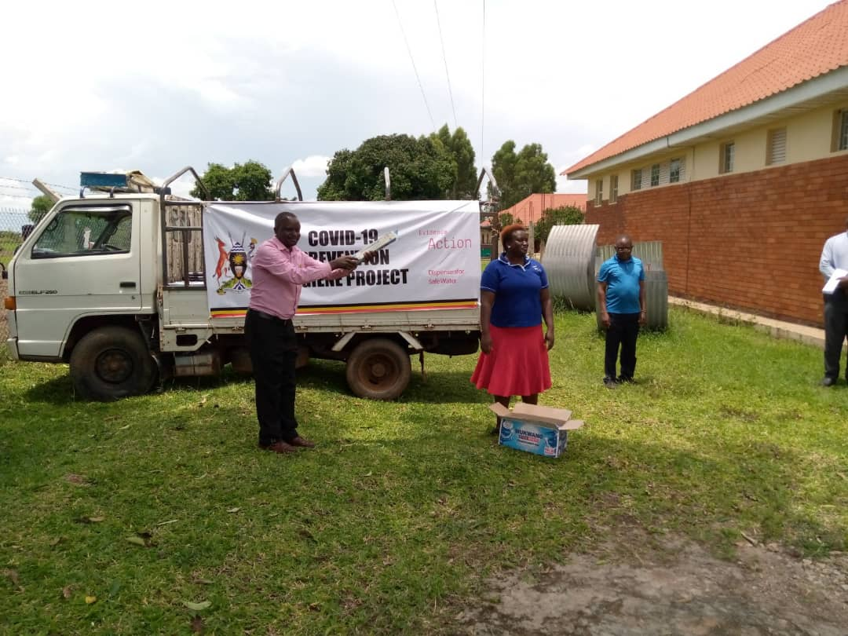 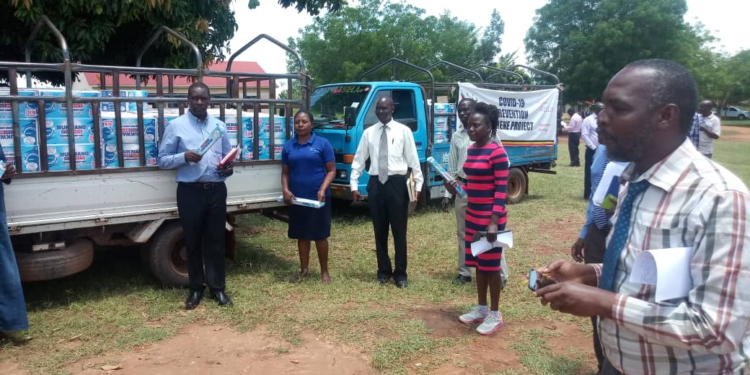

**Launching the exercise at the different district headquarters**

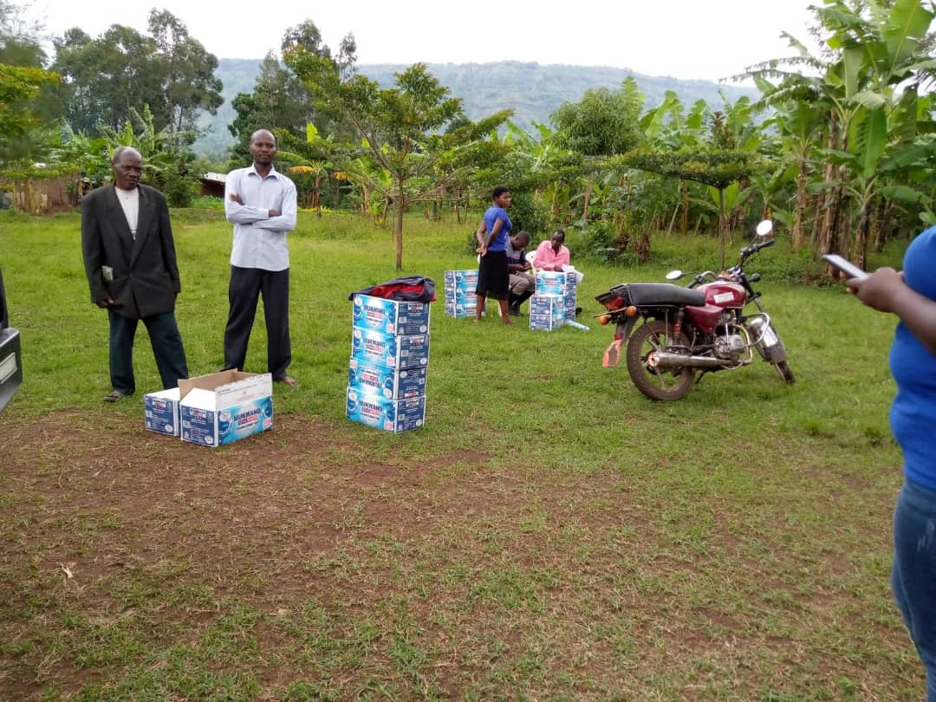  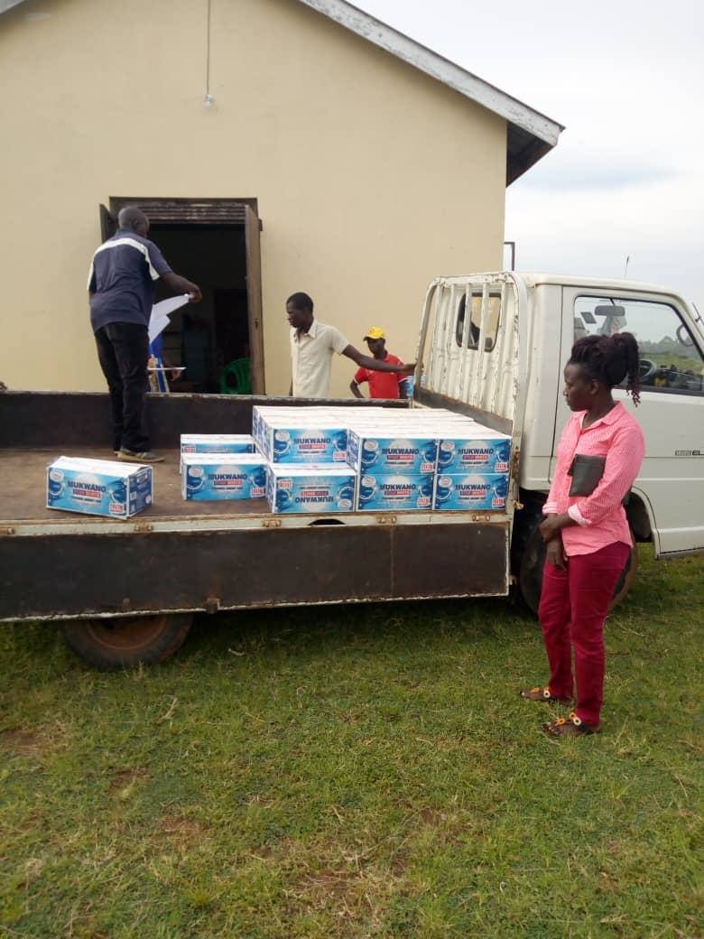

**Distribution at the sub-county level**

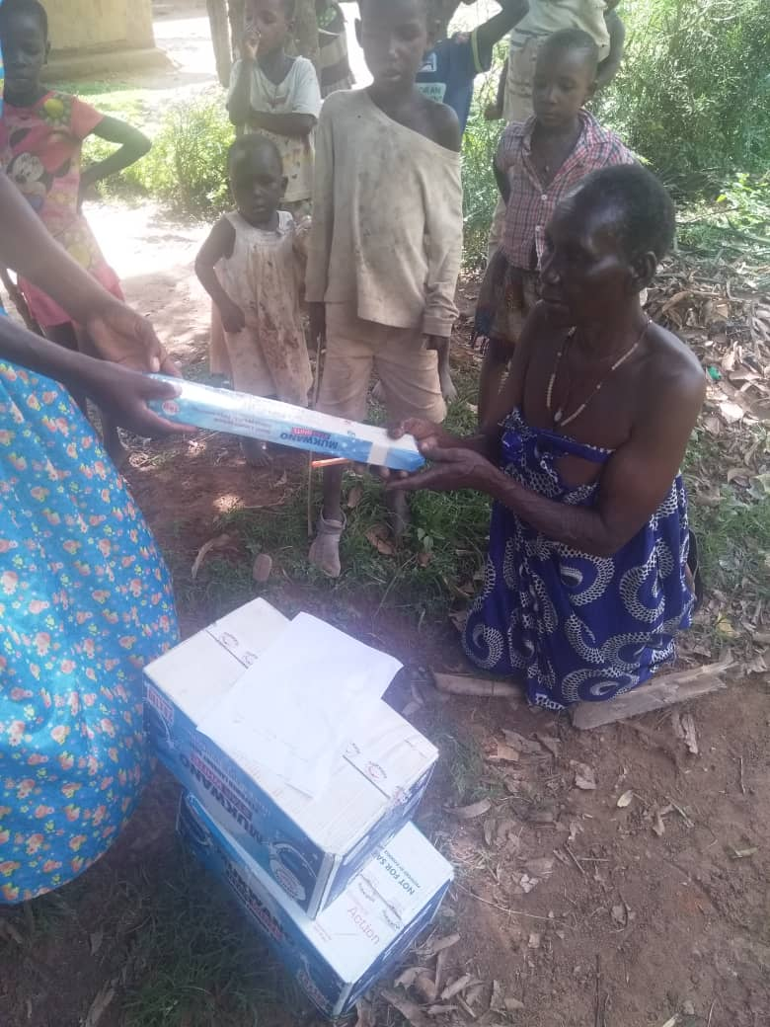

**Distribution of soap at household level**

**SOAP DISTRIBUTION PER DISTRICT**

|  |  |  |
| --- | --- | --- |
| **Serial number** | **District** | **Number of bars of soap/households** |
| 01 | Kibuku | 19403 |
| 02 | Budaka | 20132 |
| 03 | Namutumba | 15995 |
| 04 | Tororo | 31636 |
| 05 | Butebo | 15042 |
| 06 | Mbale | 24276 |
| 07 | Sironko | 22080 |
| 08 | Palisa | 38101 |
| 09 | Butaleja | 20632 |
| 10 | Manafwa | 11558 |
| 11 | Namisindwa | 19871 |

In addition, Evidence Action distributed 5700 handwashing stickers and 5700 talking points on Covid19 prevention to their promoters. Before they provided the above-mentioned IEC materials to promoters, Ministry of Health team and their staff oriented the promoters about handwashing practices and how to promote Covid19 prevention behaviours.

**CHALLENGES**

There were delays by district taskforces notably Mbale, Namisindwa and Palisa in deciding on the modalities for distribution at the lower levels. However, the Ministry of Health team liaised with the respective taskforces and the activities commenced albeit not in line with the set schedule in some cases.

During distribution of soap, we realized that the number of households in the catchment area was more than what Evidence Action had in our records. This led to some households missing soap.

**PLANS FOR NEXT ROUND.**

Evidence Action has planned to undertake the following during the next round starting on May 4th 2020 and they still need our support;

* Distribute 240722 bars of soap to households in 11 districts.
* Donate 550 boxes of soap to 11 district task forces.
* Provide 11400 promoters with 11,400 one litre disinfectant bottles.
* Donate 1100 one litre disinfectant bottles to 11 district task forces.
* Distribute 17,100 Covid19 IEC posters in 11 districts.