Comments – Marijke – 20/08/2020

* Can we delete all numbering for pillars everywhere on the site, please.

**Landing page**:

* Narrative key highlight. Please make this a written news update, rather than linked to the SitRep. We’ve had a lot of feedback on the discrepancy in data. This narrative space can also be used for updates beyond the SitRep: update from a district or on the next high level meeting or on ongoing work etc. Let’s change the title to ‘latest update’.
* Please add a ‘last updated date’ to the ‘cases by district map’
* Please add a ‘last updated date’ to the ‘4Ws map’
* Cases by district map takes very long to load.
* Data highlight was updated while I was on the site (evening of 20/08), yet date shown was 19/08 at 12 am. Is this correct?

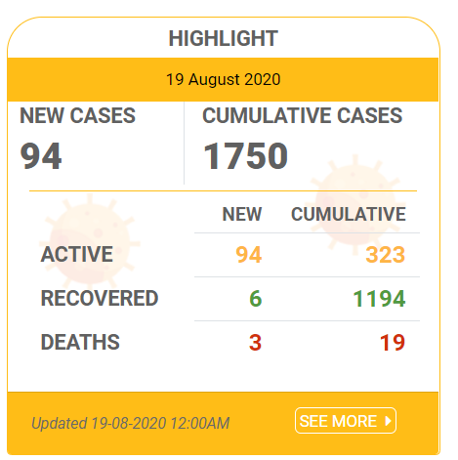

**Navigation**

* TOP Navigation: On my computer this doesn’t fit on one line, ‘logged in’ jumps to the next line.
* I feel sign up/ sign in can just be ‘log in’ since the sign up is explained when you click ‘log in’



* FOOTER navigation: should be adapted to match the changes: ‘pillar dash board’ should be changed to ‘pillar resources’ and if there’s space we should add ‘log in’.

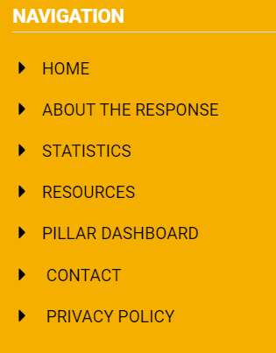

**Contact us**:

* No longer used to request log in, should be removed from text on the top
* To suggest resources to be added to the document repository *or other sections of the website* (please add this).

**Log in:**

Request log in:

* Add option to request access to ‘all resources’
* Add option to request access to ‘data dashboards’

Log in screen:

* Please change this text to: logging in will allow you to access restricted access resources as well as the vulnerability dashboard and Point of Entry data dashboard.

If you do not have credentials, you can *request them* *here*.

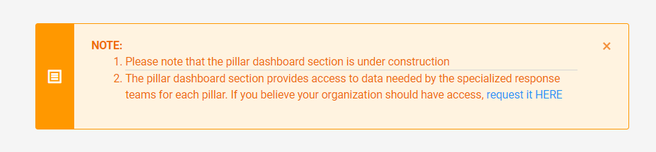

**The Uganda response to Covid-19**:

* Pillar names need to be changed on the main page (it seems like this was done on the individual pages)
* Delete pillar numbers on each pillar page.

**Covid-19 in the region**:

* Please include the source for the data.
* Is this automatically updated in real time? If not, please include a date for ‘last updated’.

**Statistics**:

* Filter, there is no button to clear the filter!
* Filter, I tried a selection from 06/05/2020 until 26/05/2020, but got results from 19/07 until 18/08



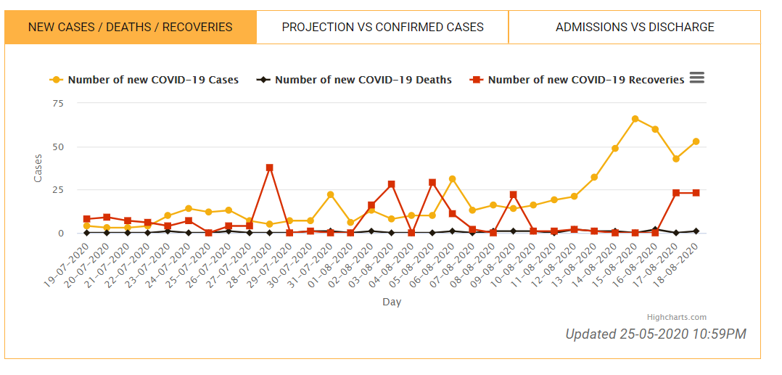

* Does the filter include the pies, pyramids and doughnuts? If not, we need to make explicit what data is filtered and what not. If yes, we can leave it as all graphs on the page are filtered.
* I tried to do a second test with the filter, but it was no longer working (the calendar opened, but could not select a date).
* Admissions graph: not in ICU cannot be more than the total admitted

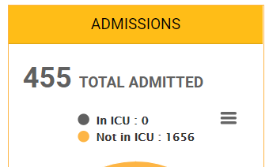

* It says updated on 25/05/2020 on the ‘new cases graph’, surely that’s not correct? Please check this on all graphs.

**Document repository**:

* Change title to ‘recommended resources’ rather than ‘recommended’.
* Please make the search bar stand out more.
* It shows 165 entries as recommended; I presume this is because we have tagged this many as recommended? Or is there a mistake in the system? Please check.
* Partners at the bottom is empty.
*  Please add space between ‘in.’ and ‘To’
* Can we delete the 182 in one of the two following places: 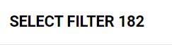 or . Also, this should be ‘resources’, not ‘links’.
* Filter pillars: Delete the pillar numbering (pillar 1, pillar 2 etc), also in the title when this filter is clicked, please.
* Filter pillars: I don’t think it’s relevant to see ‘others’ here since it’s not a pillar.
* Filter location: what is this:  This doesn’t bring up a resource.

**Key contacts**:

* Delete number in front of pillar in filter

**Pillar resources**:

* Delete number: ‘pillar 1’, ‘pillar2’ etc.
* Shouldn’t the latest updates box be a little wider?
* 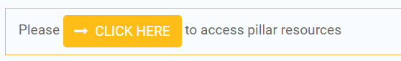 this should be ‘please click here to access all pillar resources.
* This should be ‘click here to read more about the pillar. It should link to the correct pillar page, not the general ‘the Uganda response to Covid-19’ page
* Sub-committee should be sub-pillar.
* Should we lessen the gap between the box with the details about the chair and the box with the details of the sub-committees?

**Data dashboards** (in the backend):

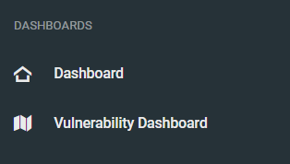

* There should be two here:
  + Vulnerability dashboard
  + Point of Entry dashboard
  + (please delete the continuity of care dashboard)

**General backend**:

* Add a simple narrative landing page for the user profile that explains what it is they can access additionally and how to go about it (click home page on top to continue using the website but with access to all resources, access data dashboards from backend). I’m available to discuss this further if necessary.